**Outputs**

**1.Creating a key without time-to-live property**

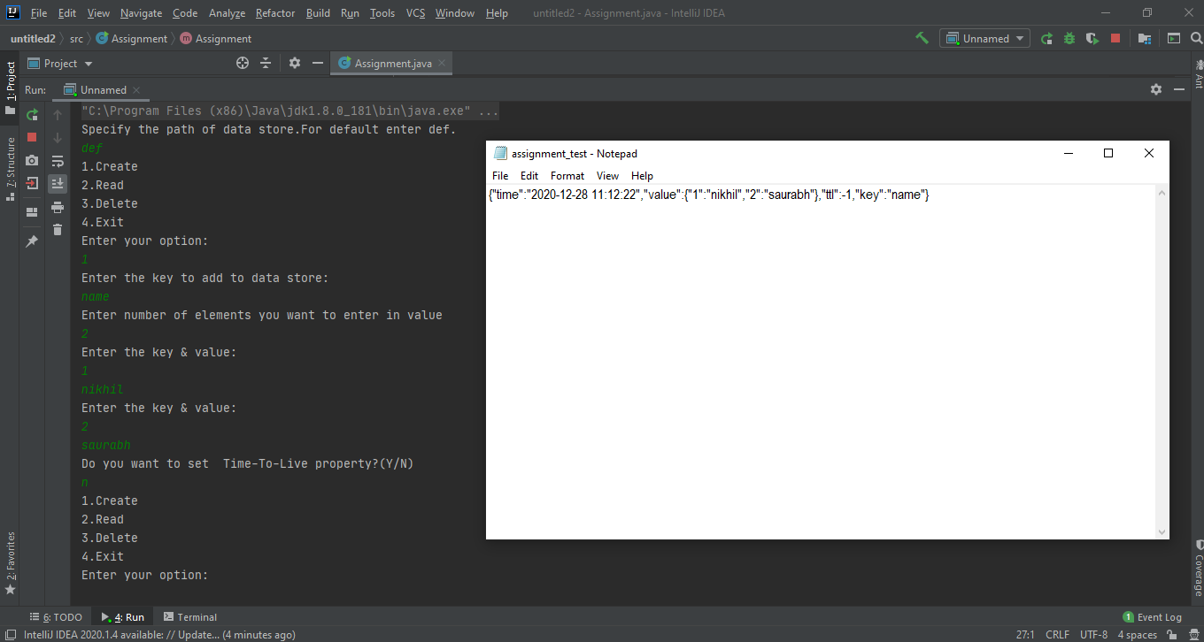

**2. Creating a key with time-to-live property**

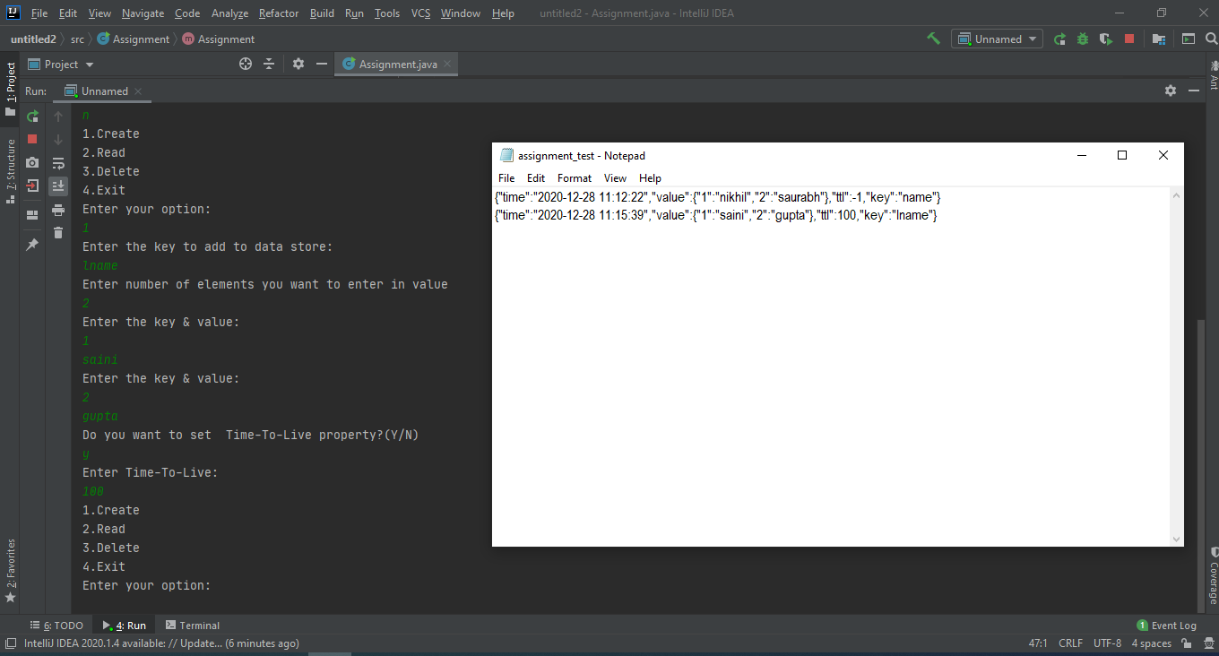

**3. Create is invoked for an existing key (error: key already exist in data store)**

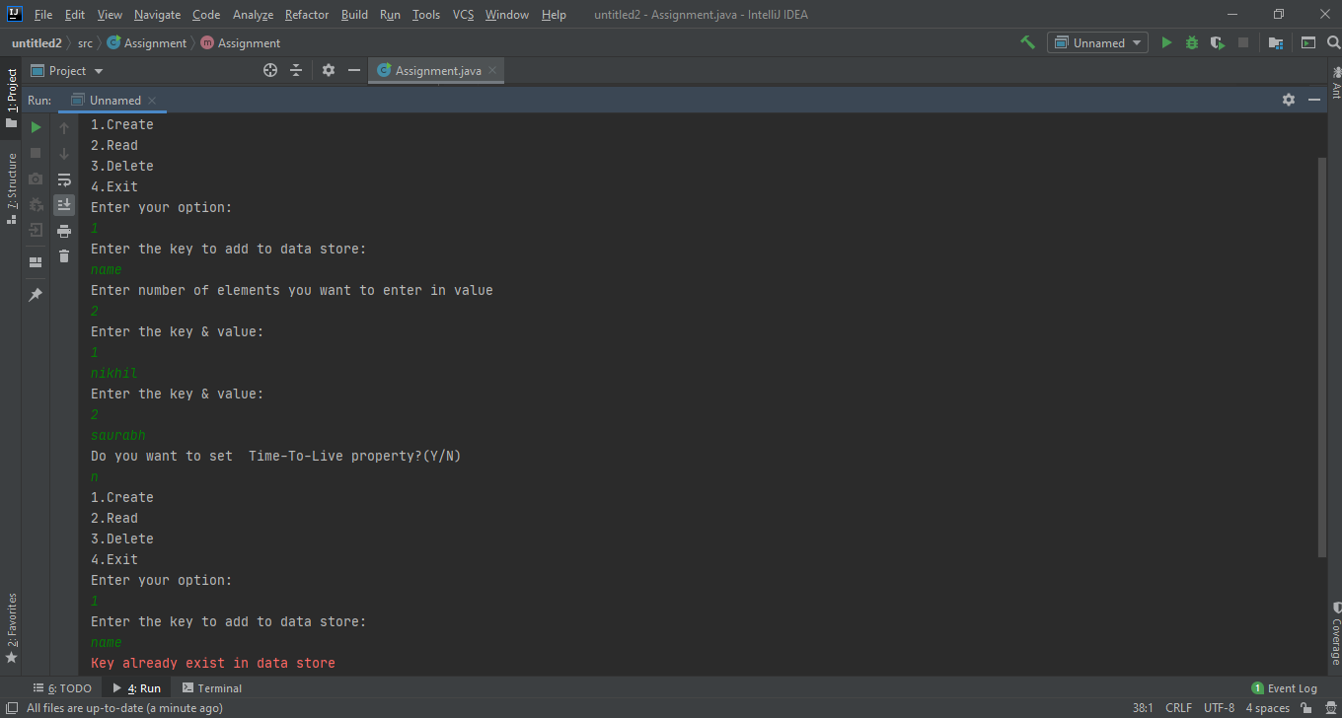

**4. Read operation**

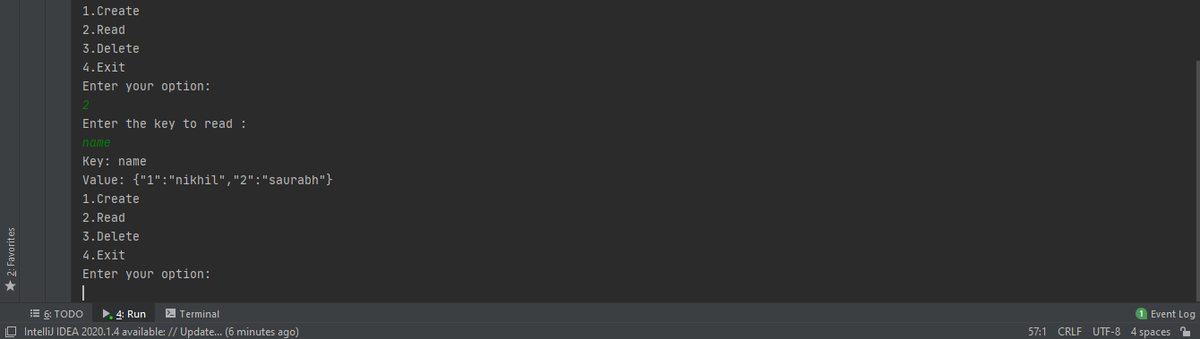

**5. Delete operation**

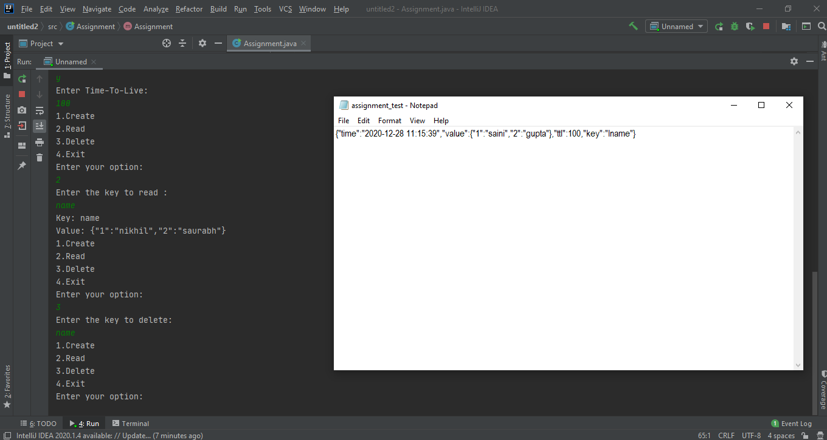

**6. Reading a non-existing key in data store**

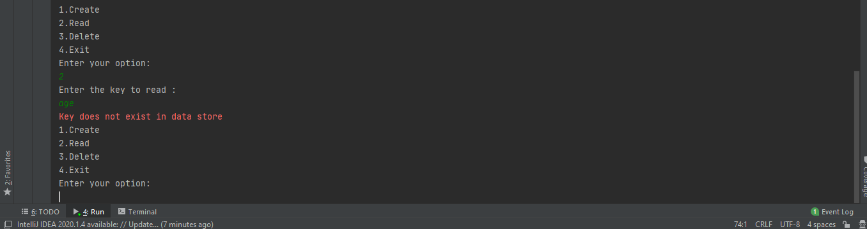

**7. Deleting a non-existing key in datastore**

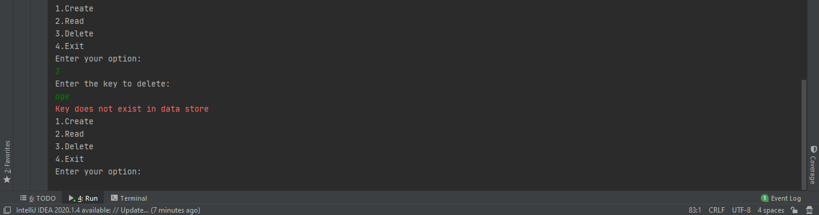

**8. Reading a key for which time-to-live has expired**

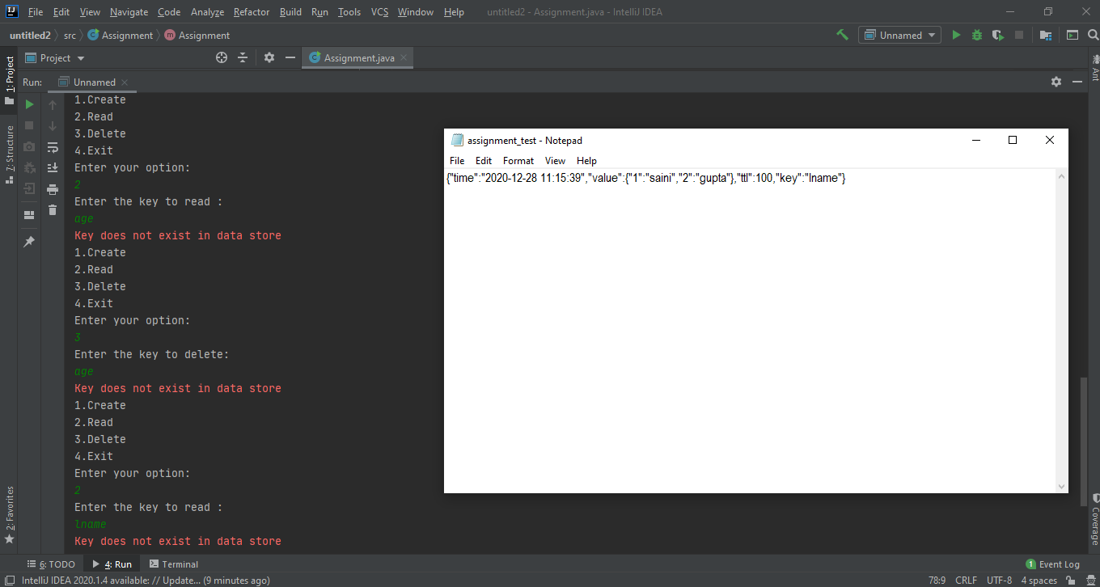

**9. Creating a key more than 32 characters**

